**Name:-Archana Kumai Reg. No.:- ADIT22AP01590** **DATE:11/01/2024**

**PRACTICAL EXAM OF ELECTIVE MODULE 1**

**(SET-B)**

**Qes:-**

1. Create a database and document using cloudent.
2. Load an external data(CSV) using db
3. Customize your IBM Cloud DashBoard.

1. **Practical Name:-** Load an external data(CSV) using db2.

**List of Hardware Requirement:-**

1. Working PC/Laptop
2. OS: Windows 10/11, or MacOS, or Linux distributions.
3. Web Browser: Microsoft Edge, Google Chrome, Mozilla Firefox, Brave or any compatible browser.
4. Now, I am using Google Chrome

**List of Software Requirements:-**

* + 1. IBM Cloud,
    2. Internet

Technology

1. IBM Db2

**Description:-**

IBM Db2 is the cloud-native database built to power low-latency transactions and real-time

analytics at scale

**Steps of Practical:-**

Step 1: Open IBM Cloud in my browser.

Step 2: Fill in my ID & Password as per the prompt and click login

Step 3: i would be redirected to our dashboard

Step 4: Click on Catalog, to navigate to different resources available.

Step 5: I might go for databases or search for db2 from the catalog search

Step 6: This lists all the database type available on IBM Cloud. Slide down a little to navigate to db2. And open it

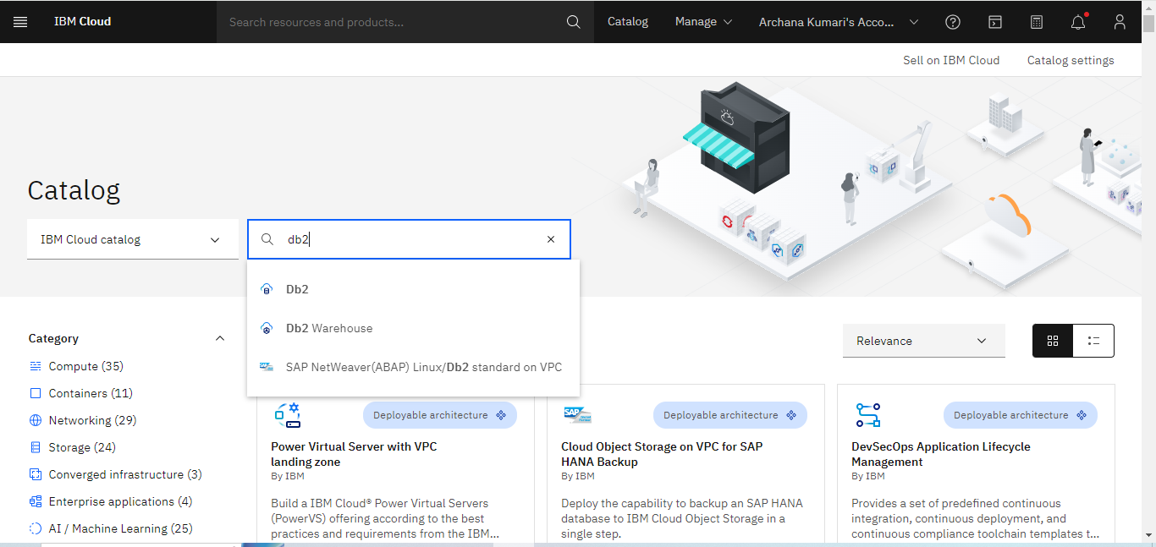

Step 7: I am now on CREATE RESOURCE page. I have selected LONDON as region & Free Tier selected.

Step 8: Slide a little for options to configure my resource. And CREATE.

rename my services , electiveexam

Tags:- to identify the phase and version I giving tages ; env:prod; env:test; env:deploy; ver:1

Access Management tags:- access:client access:dev

Then I fill Check box after I click on create button

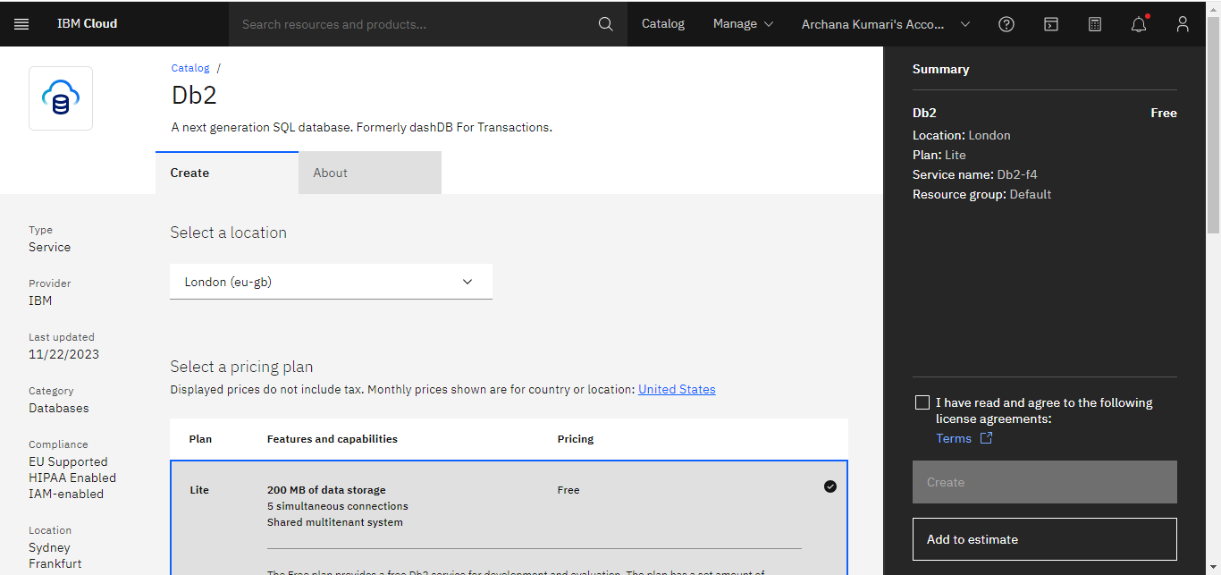 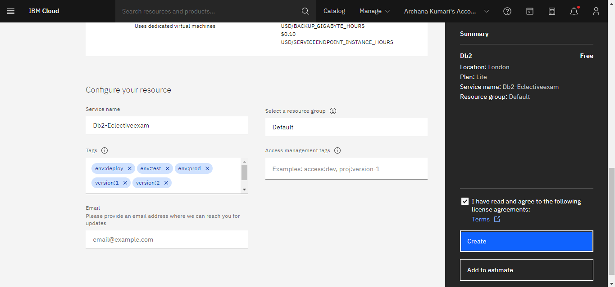

**Step 9:** Go to Resources list database then we will see in this lists all the database available on IBM Cloud. Slide down a little to see db2-Test And open it

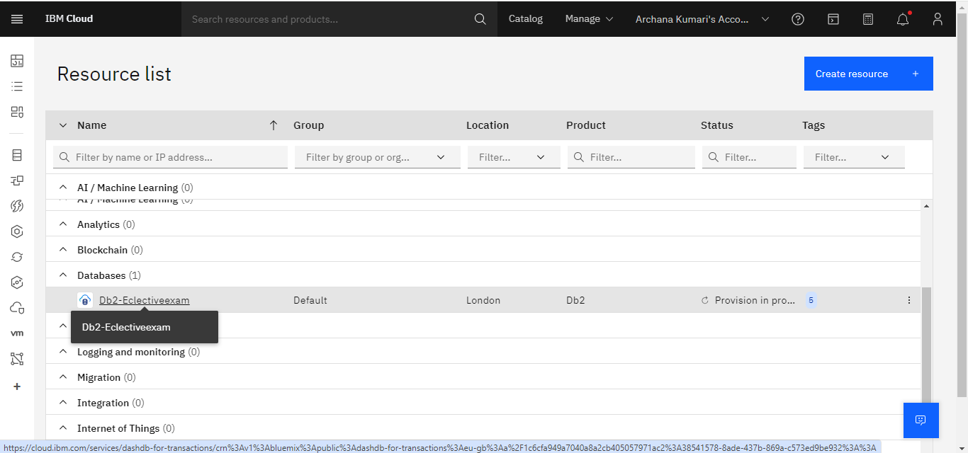

**Step 10:**

clicking on “GO TO UI”, to be redirected to an OVERVIEW page

Now, I am in resource list everyone see here in database electiveexam click on it

Then jump on and from here navigate to the UI, by

clicking on “GO TO UI”, to be redirected to an OVERVIEW page

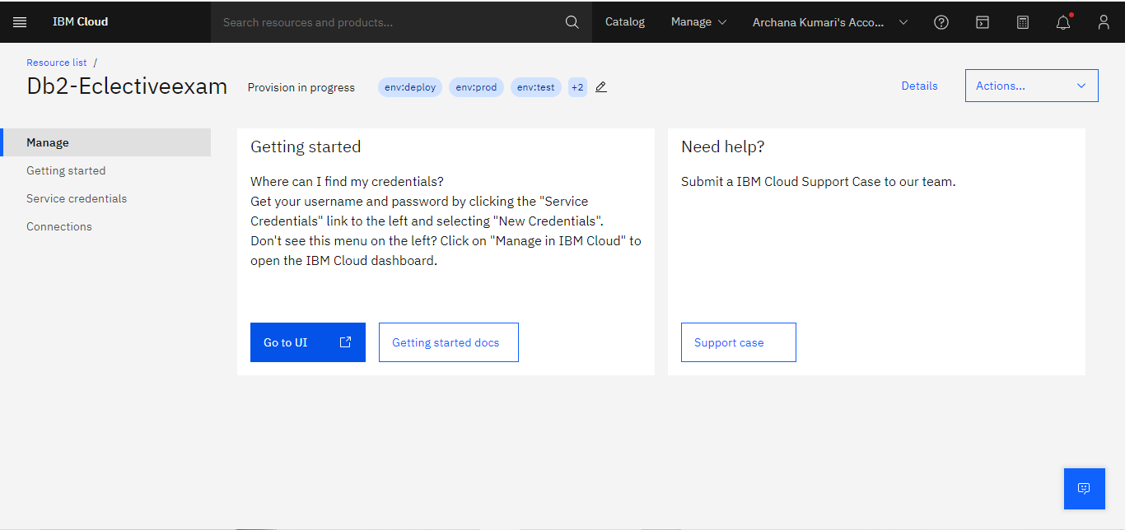

Step 11: You might upload your data here. The schema would read the imported file and adjust

accordingly. You would be allowed to import locally from your machine or from IBM Cloud storage & AWS S3.

Let’s import from a local file. Scroll a little to drag files. We would select a local file, and open to upload

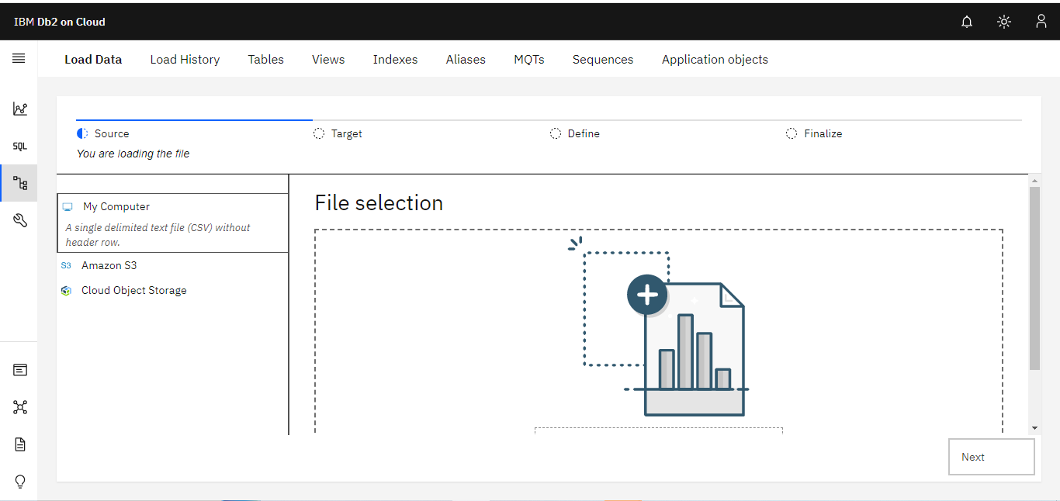

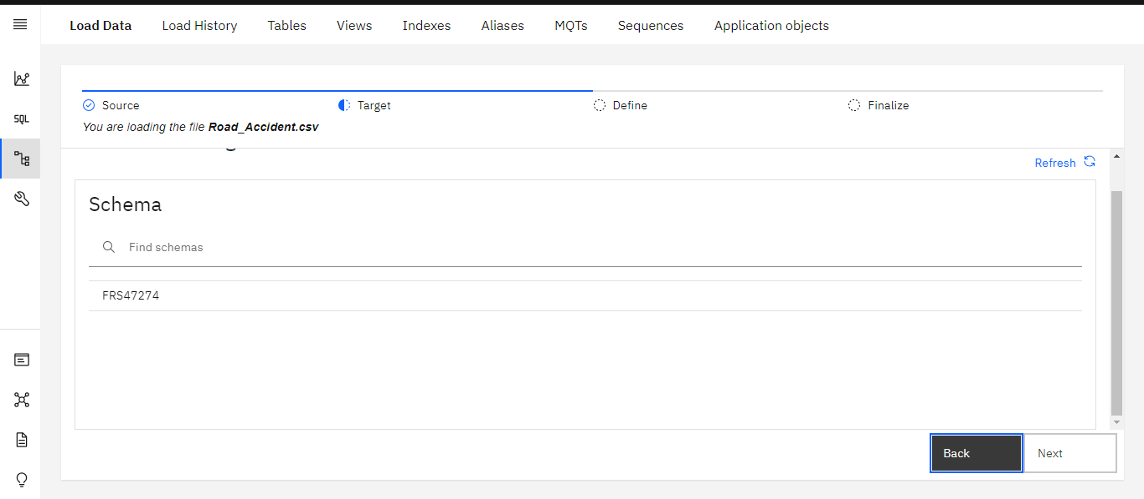

Step 12: Create a NEW TABLE. You would be prompted to provide a name to the tableI am adding the table

Aditelectiveexam, and the CREATE button would be highlighted.

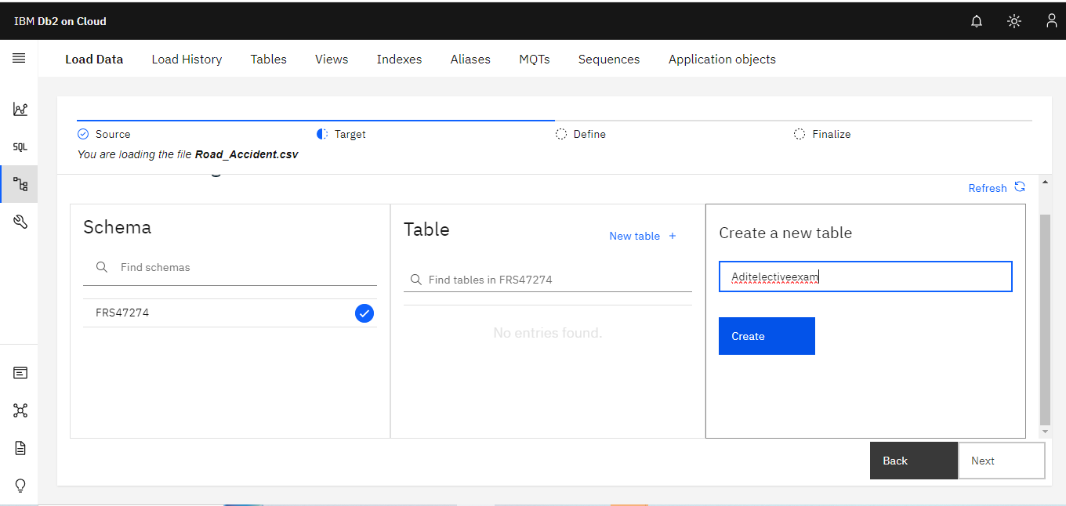

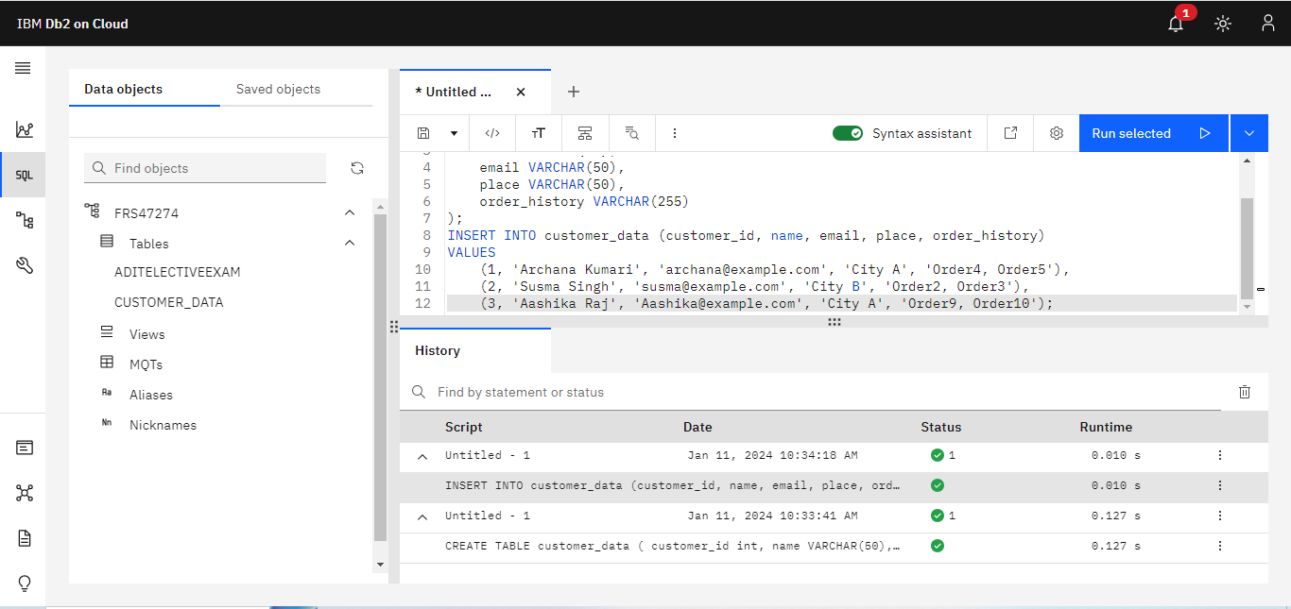

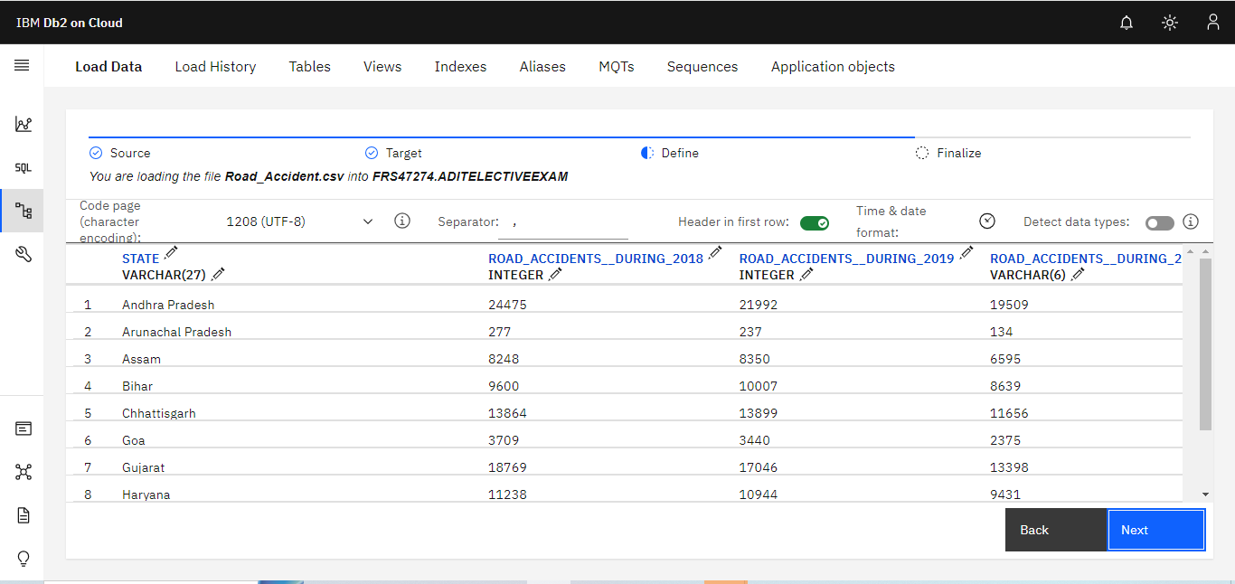

Step 13: Then click on begin load

This starts the LOAD process, that might take a few seconds to be ready. A few records

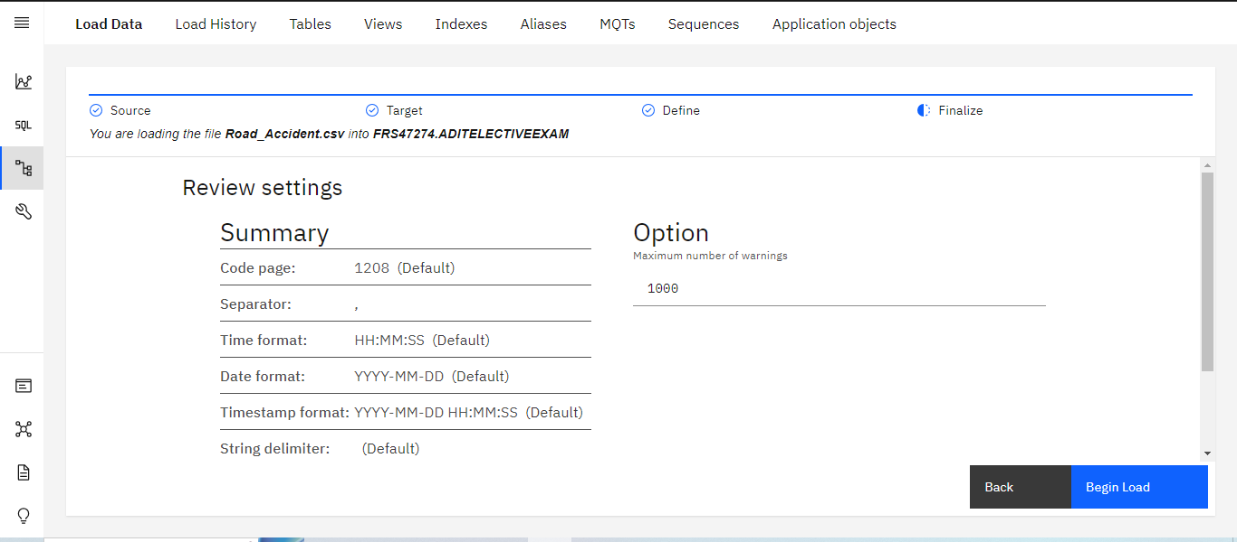

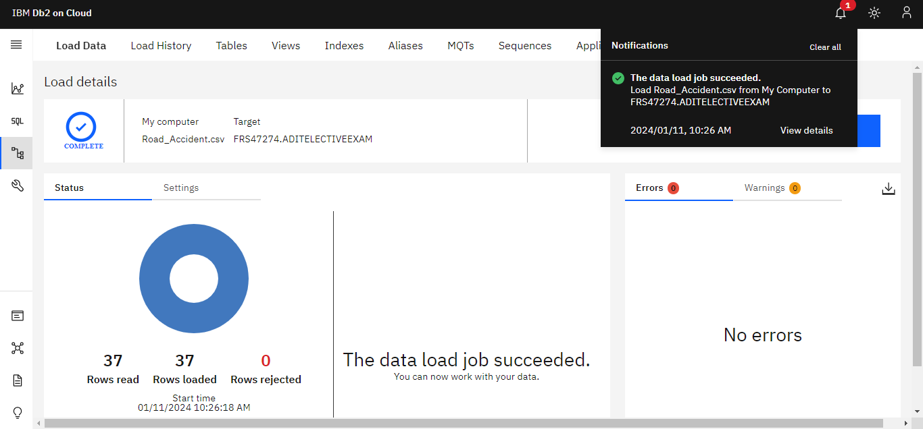

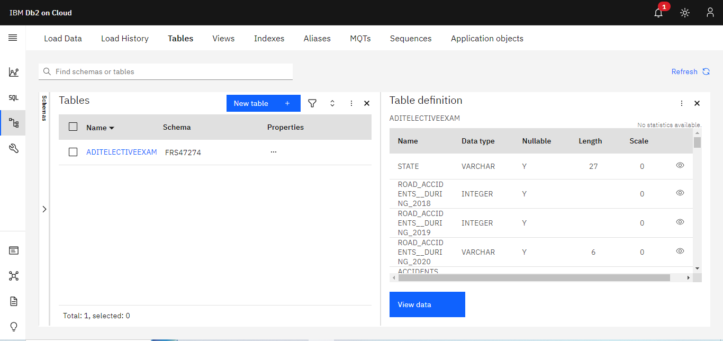

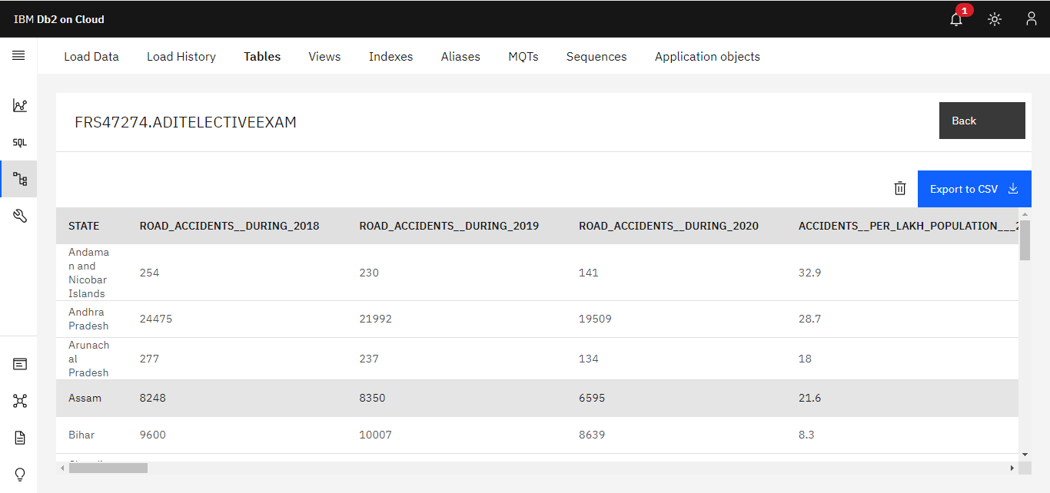

**Output:-**



**Practical:-1** Create a database and document using cloudant.

**List of Hardware Requirement:-**

1. Working PC/Laptop
2. OS: Windows 10/11, or MacOS, or Linux distributions.
3. Web Browser: Microsoft Edge, Google Chrome, Mozilla Firefox, Brave or any compatible browser.
4. Now, I am using Google Chrome

**List of Software Requirements:-**

* + 1. IBM Cloud,
    2. Internet

Technology

1. cloudant

**Step1:** Go to catlog And search on search bar Cloudant and click on it

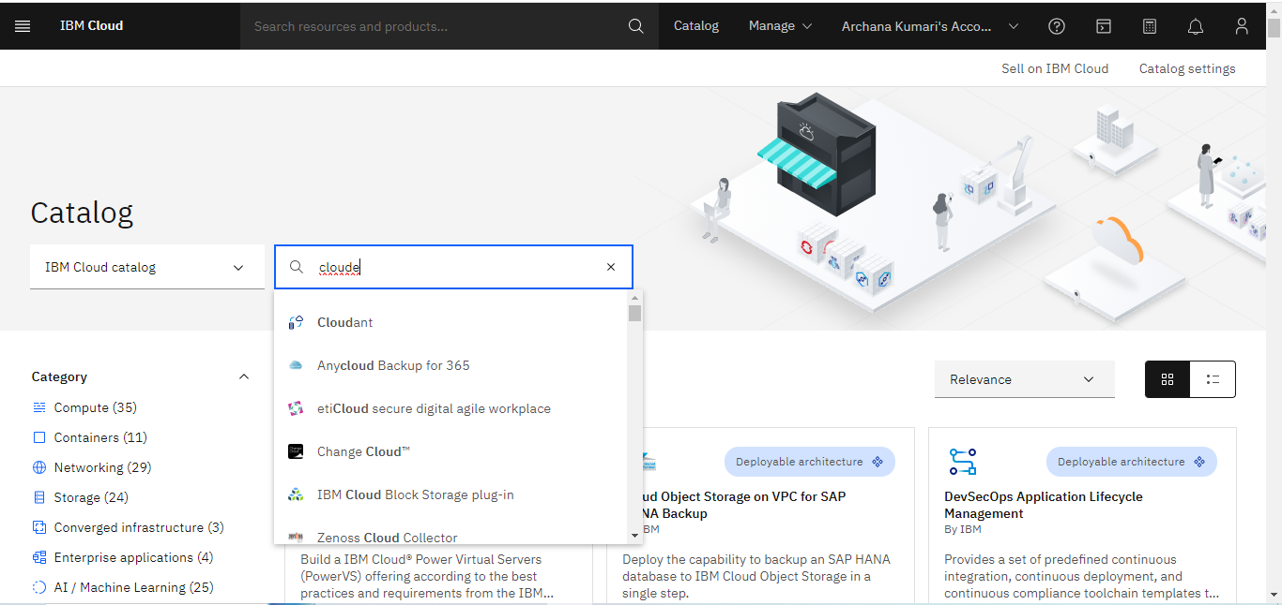

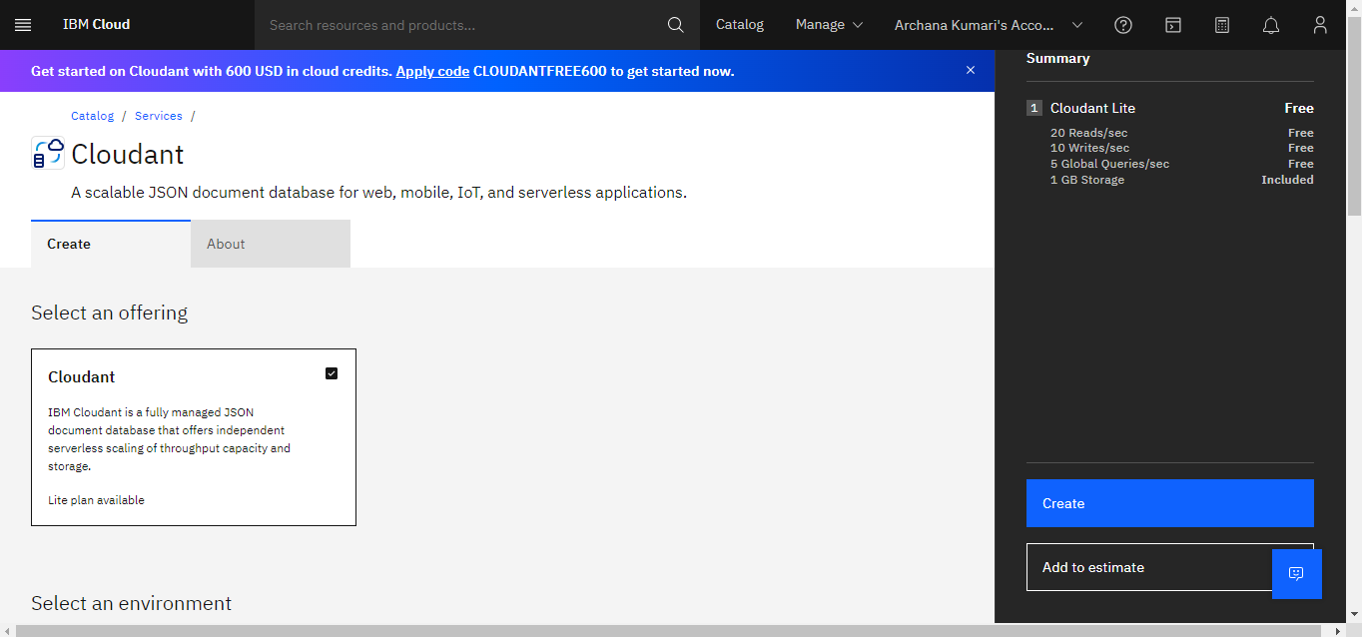

**Step2**: Now create a Cloudant Database.

Let everything keep as it is, you might rename the database INSTANCE NAME,

I instance number name is and Click on create.

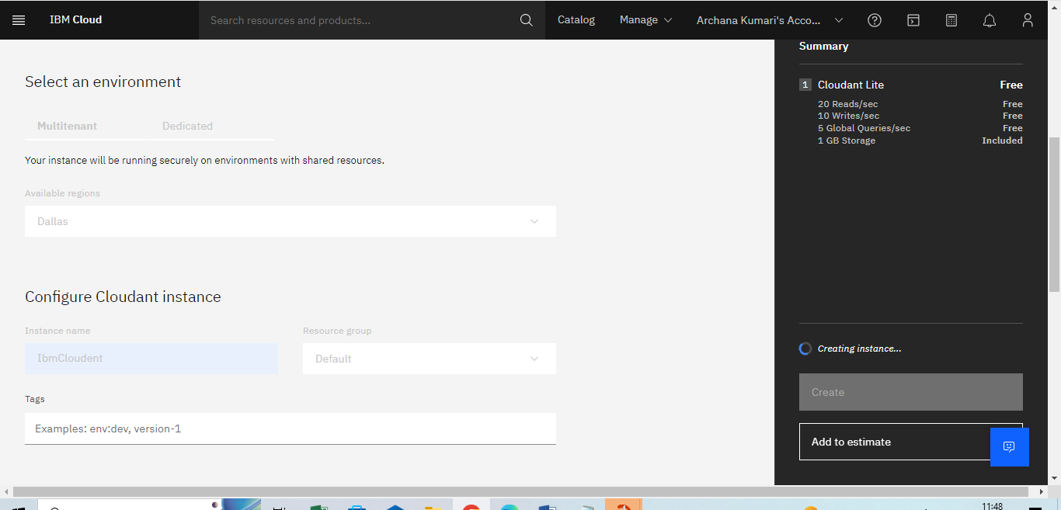

**Step3:** It redirects you to your resource list, after getting provisioned, you might start

Open the service you created.

Click on the database name.

It will take you to another window like this. you have deployment methods listed

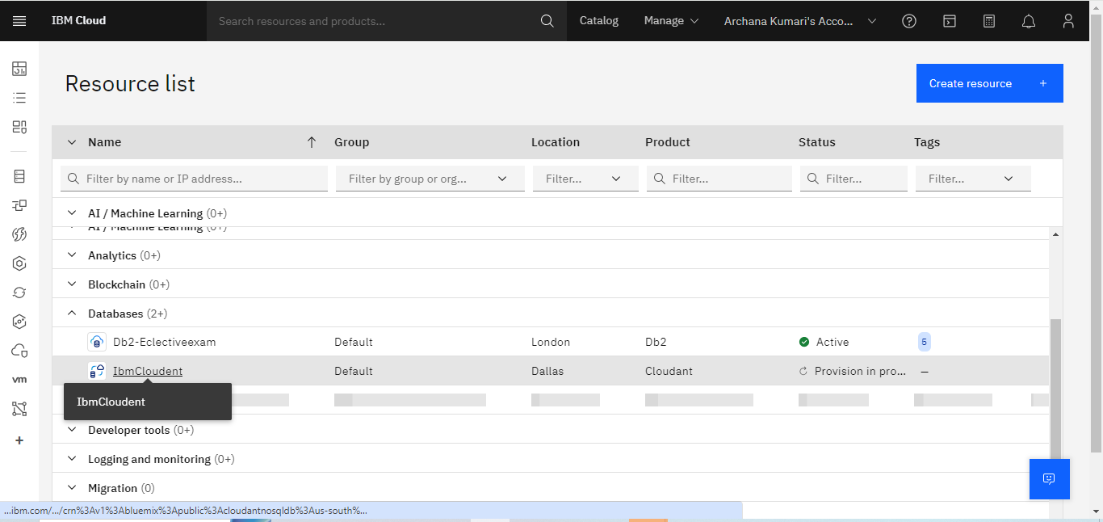

**Step4:** Now lunch the dashboard, to get a new window

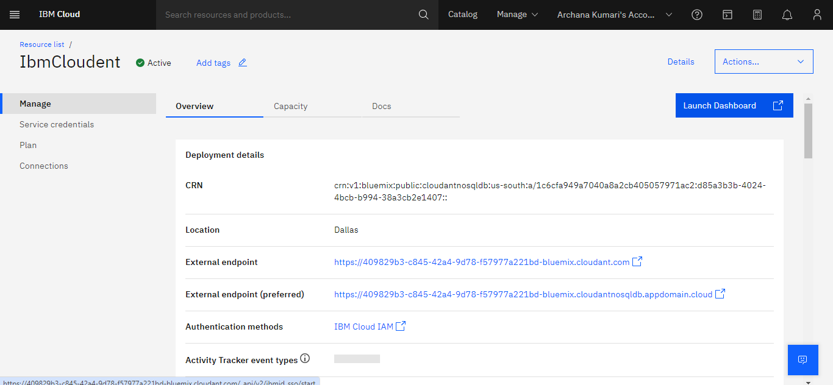

Step5: Create a DATABASE

Give the Database Name , you might keep the field default

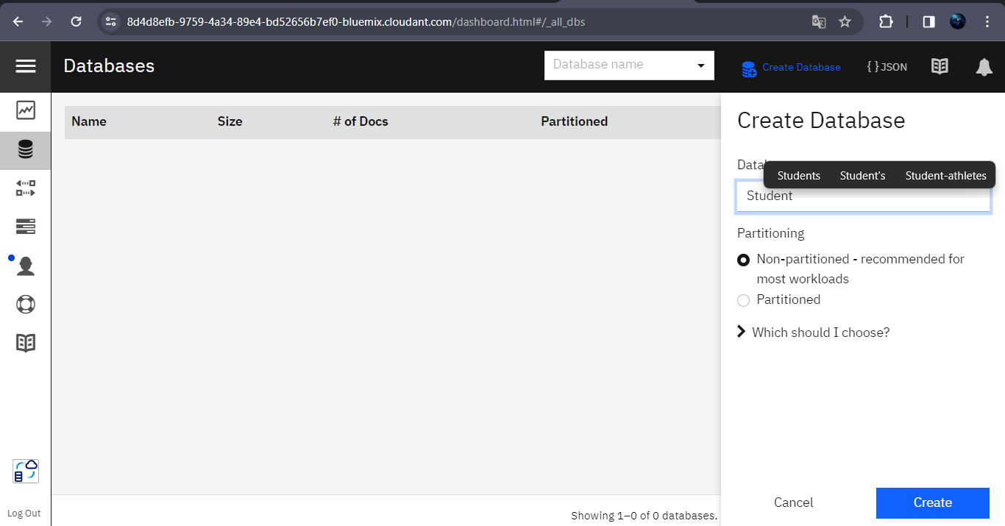

Click on database name and select the database created

Now you can create NoSQL Collection.

{

"_id": "A101",

"_rev": "1-b4aa4e6b20fc66d6724d790652a8e3c1",

"Student": "Archana",

"Course": "ADIT",

"Phone": "6287967301"

}

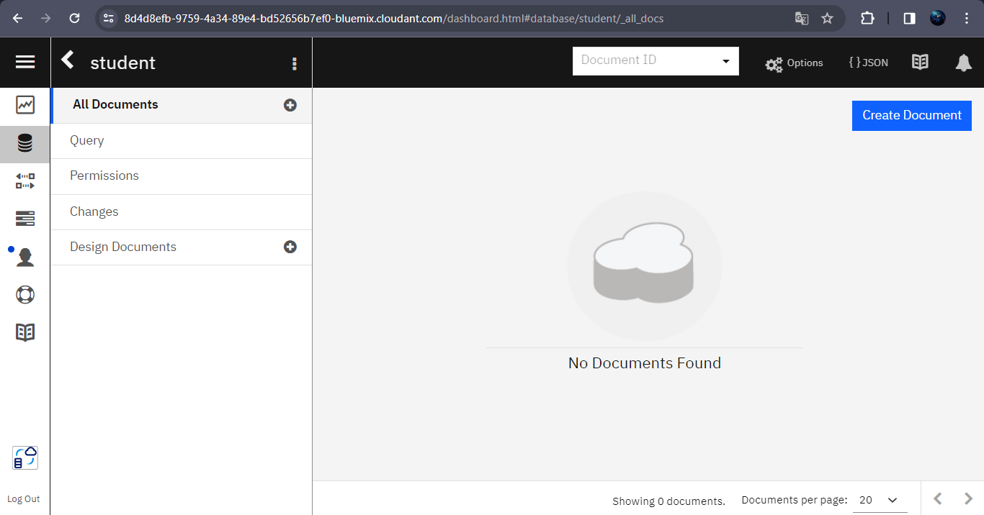

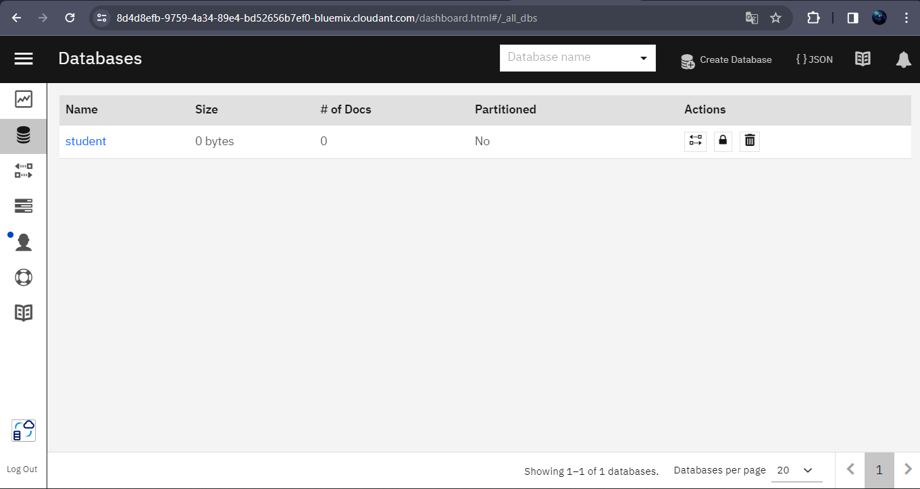

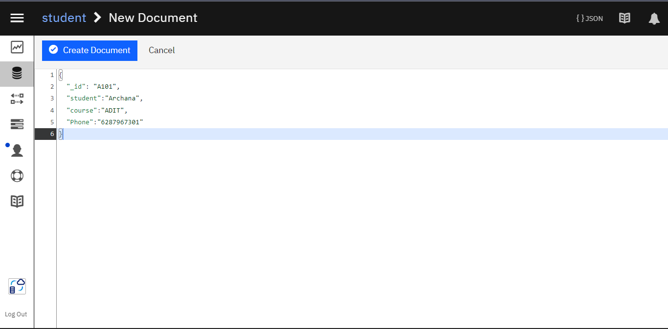

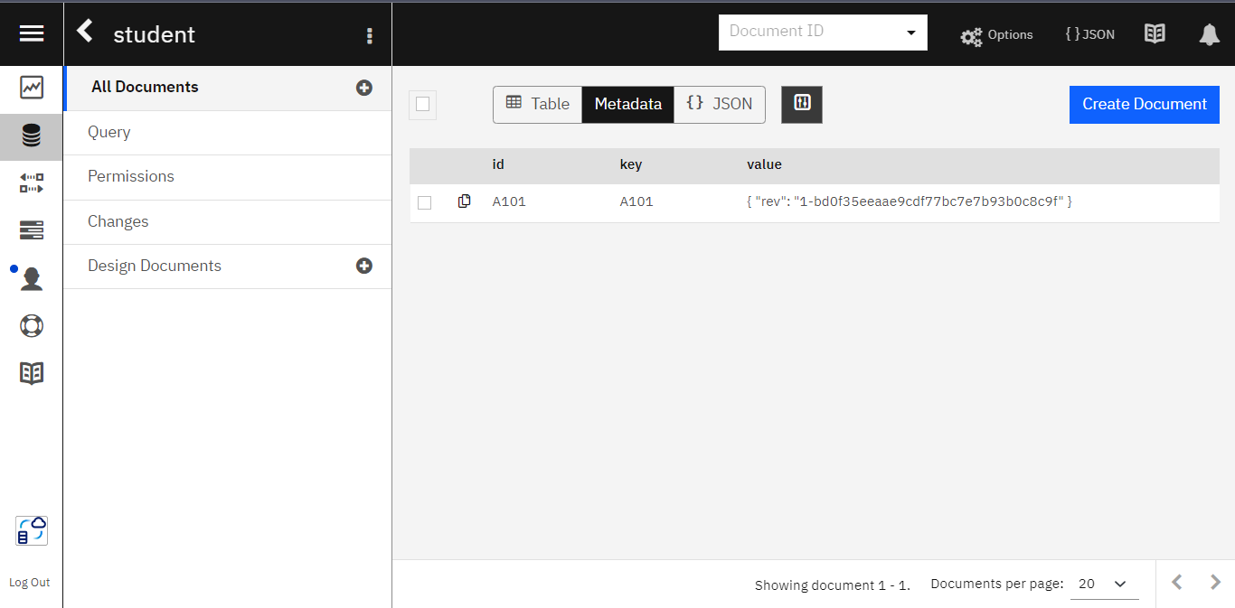

Step6: Default view of the collection is METADATA, but you can change to TABLE VIEW or JSON format

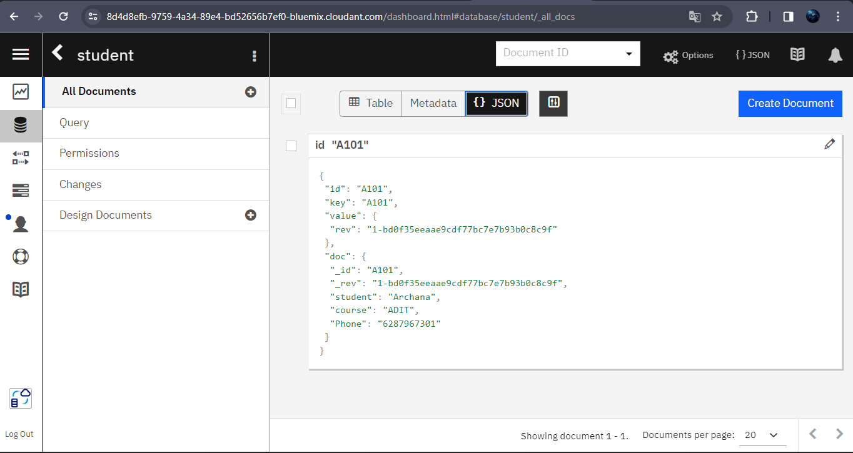

**Practical No:-4** Customize your IBM Cloud Dashboard.

**List of Hardware Requirement:-**

1. Working PC/Laptop
2. OS: Windows 10/11, or MacOS, or Linux distributions.
3. Web Browser: Microsoft Edge, Google Chrome, Mozilla Firefox, Brave or any compatible browser.
4. Now, I am using Google Chrome

**List of Software Requirements:-**

* + 1. IBM Cloud,
    2. Internet

Technology

1. Dashboard

**Step 1: Create a dashboard**

First, create a new dashboard and select a template.

1. In the IBM Cloud console, click the Actions icon, and select Create a dashboard

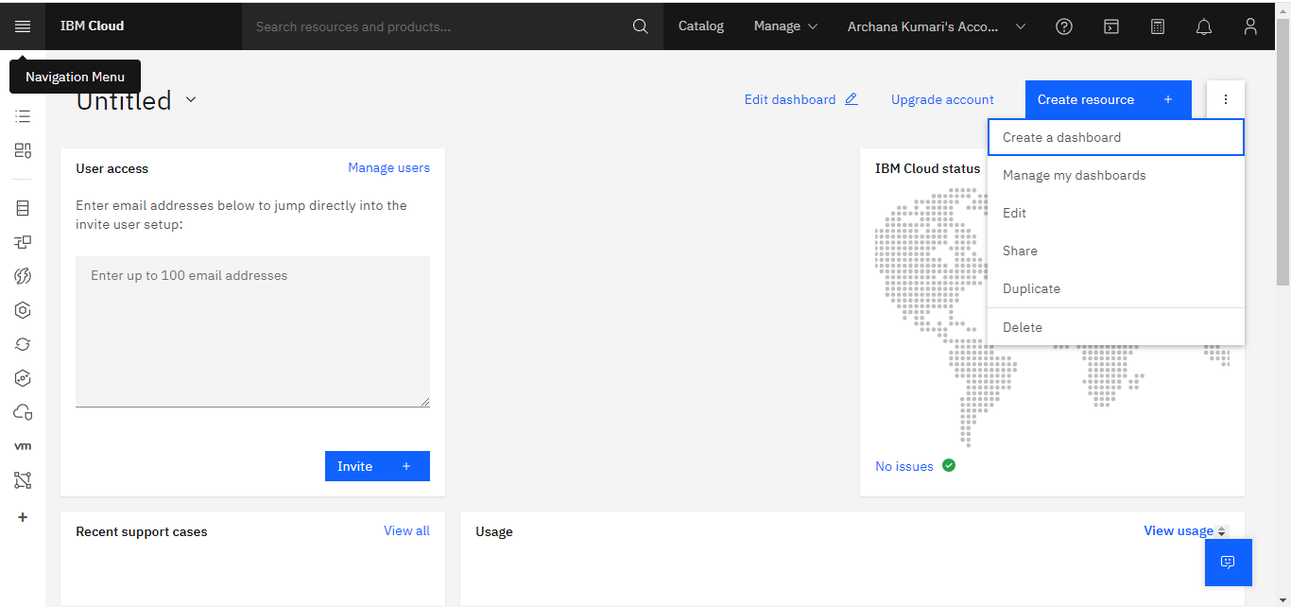

2 Select the Management template from the available options, and then click Create.

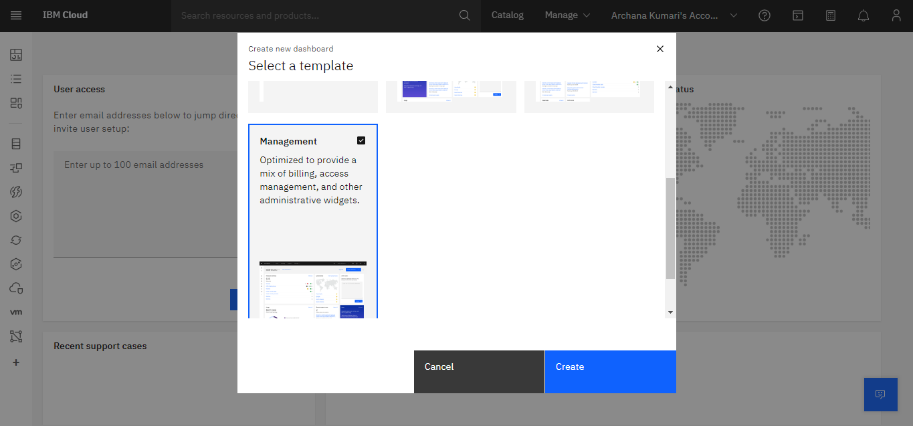

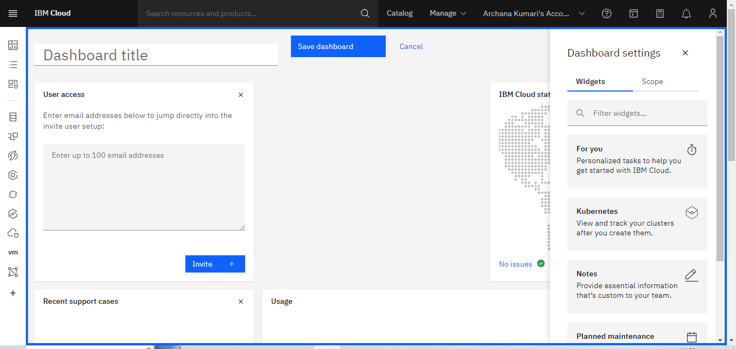

**Step 3:-** Now, I am creating Dashboard title

Dashboard name is IBM Dashboard name

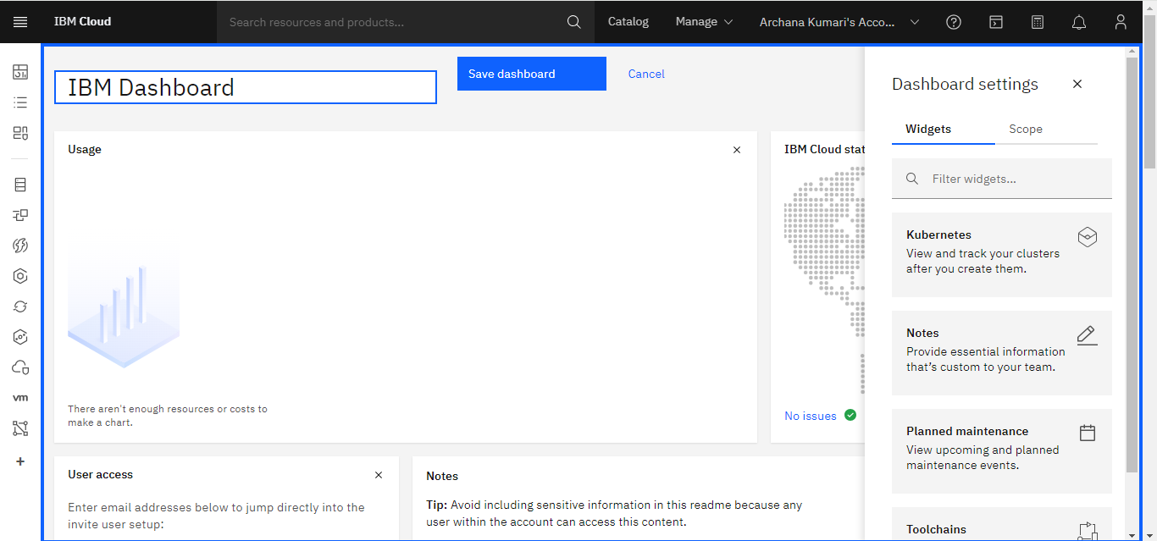

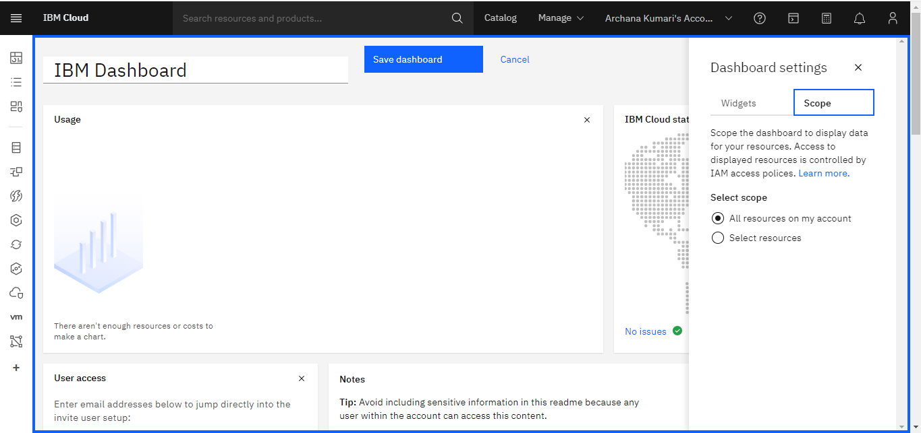

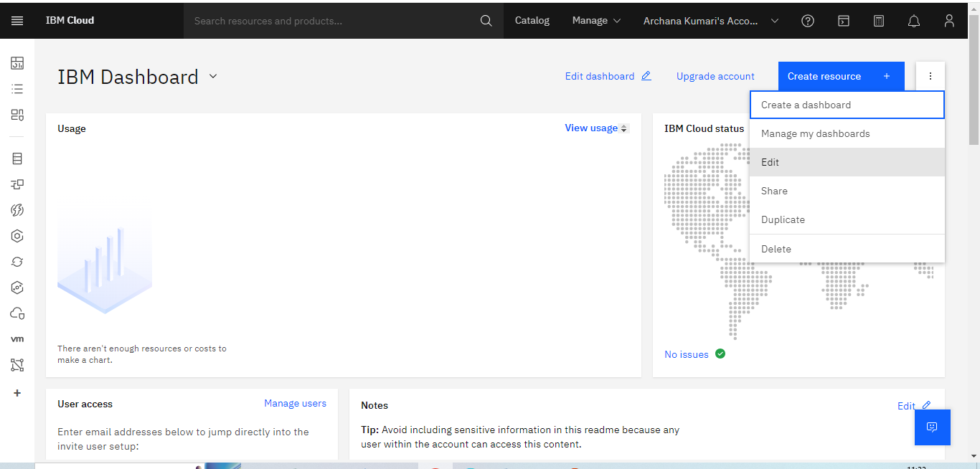

**Step 4:-** Click on three doubts here giving some option we can share then click on share then one share this dashboard

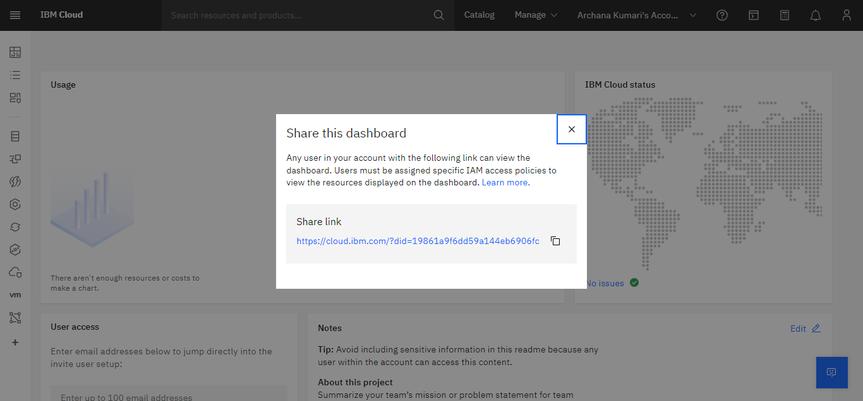

**Step 5:-** on three dout here giving some option we can see Duplicate then click on duplicate then open Duplicate dashboard after click on Duplicate

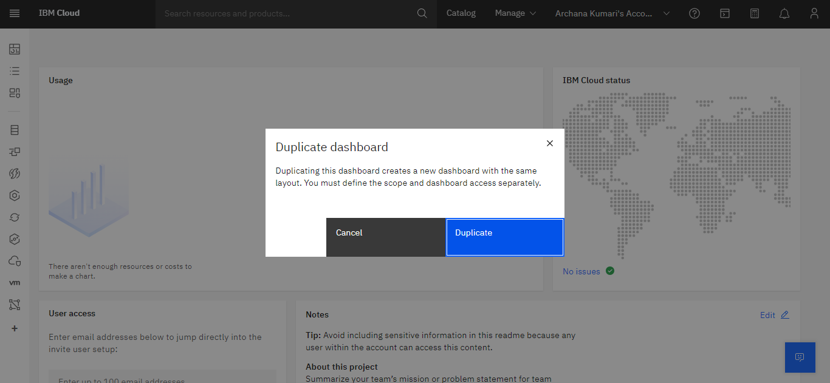

**Step 6 :-** Click on three dout here giving some option we can see Delete option then click on Delete then open Delete dashboard after click

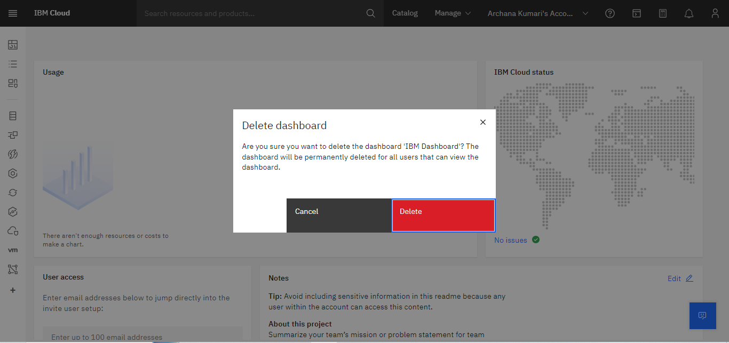

Diploma in

IT, Networking and Cloud

Elective Module-1

Cloud Computing